Syllabus – ELA800a
Ms. Tanyu – 8th grade English Language Arts (Reading & Writing)
Room 236, Ext. 160
Ms.Tanyu@gmail.com
http://www.rossarts.org/ms-lou-tanyu.html

Terms to Know:
- syllabus – an outline and summary of topics to be covered in this class
- course number – a number given to a class at college to identify the class
- essential question – the big, important concept or idea

Course Number | Description & Essential Questions (EQ) | Important Dates
ELA801a | As students end the year with Walter Dean Myers’ Monster, they will be compelled to truly think about the role society plays in our lives.  EQ: Who is stronger: the society or the individual? | 1st Quarter: 8/28/13-11/1/13  Unit Test: 10/23/12-10/25/12  Biographical Narrative: 9/27/13  Reading Task: 10/11/13  Research Task: 10/25/13  Report Card Night: 11/13/12
ELA802a | The second marking period focuses on nonfiction texts. The class novel for this quarter is Chris Crowe’s Getting Away with Murder. Students will also collaborate in small groups to analyze other nonfiction works.  EQ: How can one event change our life forever? What is justice? | 2nd Quarter: 11/4/12-1/17/14  Unit Test: 1/7/13-1/9/13  Informational Research Paper: 12/18/13  2 Choice Tasks: deadlines TBD  Report Card Night: 1/29/13
ELA803a | The third marking period also focuses on nonfiction texts. The class novel for this quarter is Disasters. Students will collaborate in small groups to analyze other nonfiction works.  EQ: How can one event change an individual or a community’s life forever? How do perspective and point-of view shape a story? | 3rd Quarter: 1/29/14-4/11/14  Unit Test: 3/17/14-3/28/14  Research-based Argument Essay: 4/9/13  2 Choice Tasks: deadlines TBD
ELA804a | In the first marking period, students will explore the concept of identity and how one’s identity is shaped. Fiction texts will be analyzed, including Kristen Randle’s Slumming.  EQ: What does it mean to be an individual? How do our peers influence us? | 4th Quarter: 4/21/14-6/18/14  Unit Test: 6/3/13-6/5/13  Literary Analysis Essay: 6/4/13  Reading Task: deadline TBD  Research Task: deadline TBD

Code of Conduct
Ms. Tanyu – 7th grade English Language Arts (Reading & Writing)
Room 236, Ext. 160
Ms.Tanyu@gmail.com

Terms to Know:
- code of conduct – a set of rules outlining the responsibilities of or proper practices for an individual or group
- motto – a saying or phrase that summarizes the general motivation of a group
- contract – an agreement in which there is a promise to do something in return

Our class motto is college-bound, self-driven.
College-bound means choosing to go to college after high school.
Self-driven means you are motivated to accomplish something for yourself.

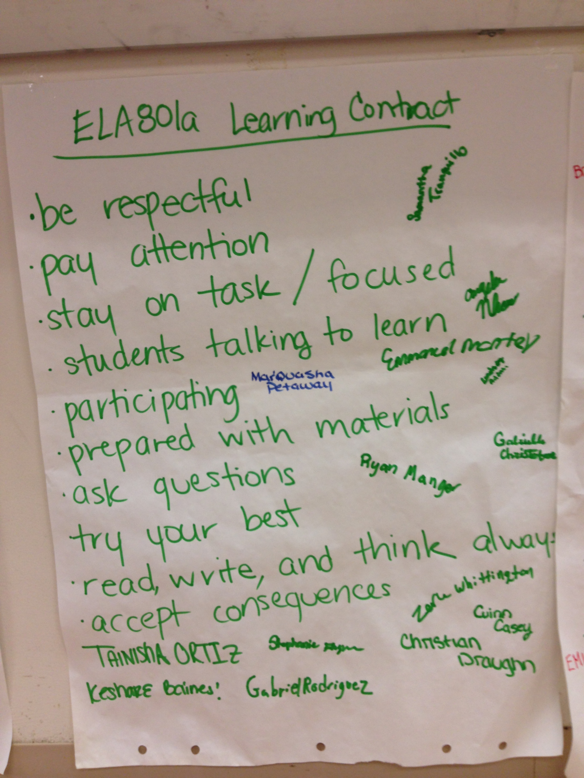
How should we act to show we are college-bound and self-driven? Our class came up with a learning contract and signed the agreement (posted in the classroom.) The learning contract this class specifically came up with included the following:

Choosing not to follow the learning contract will result in consequences (i.e. reflection paper, parent call, detention) and, more importantly, will cause the student to sacrifice valuable learning opportunities.

I acknowledge that I have read the syllabus and code of conduct for Ms. Tanyu’s class and will do my best to uphold the high standards Ms. Tanyu has set for me so that I may increase my opportunities in life.

Student’s Signature: _____________________________________________ Date: ___________

Parent’s Signature: ______________________________________________ Date: ___________

