Syllabus – 7th Grade English Language Arts, Ms. Tanyu
Room 236, Ext. 2236
Ms.Tanyu@gmail.com
http://www.rossarts.org/ms-tanyu.html

Terms to Know:
- syllabus – an outline and summary of topics to be covered in this class
- course number – a number given to a class at college to identify it
- essential question (EQ) – the big, important concept or idea

Course Number | Description & Essential Questions (EQ) | Dates & Tasks
ELA701 | In the first marking period, students will explore the concept of identity and how one’s identity is shaped in Jerry Spinelli’s Wringer. Students will also collaborate in small groups (called literature circles) to determine characterization and theme in other fiction texts.  EQ: What does it mean to be an individual? How do our society and our peers influence us? | 1st Quarter: 8/31/15-11/6/15  Required Writing Task:  Personal Narrative  Open House: Tues. 9/29/15  Report Card Night: Wed. 11/18/15
ELA702 | The second marking period focuses on nonfiction texts. The class novel for this quarter is John Fleischman’s Phineas Gage. Students will also collaborate in small groups (called power strategy groups) to analyze other nonfiction works.  EQ: How can one event change our life forever? How do conflicting sides argue and debate? | 2nd Quarter: 11/9/15-1/22/16  Required Writing Task: Informational Research Paper on Self-Generated Question
ELA703 | The third marking period also focuses on nonfiction texts. The class novel for this quarter is Eric Walters’ When Elephants Fight. This quarter will have a strong focus on building research skills.  EQ: How does conflict shape a country and its people? | 3rd Quarter: 1/25/16-4/15/16  Required Writing Task:  Research-based Argumentative Essay about a Global Issue  Report Card Night: Wed. 4/27/16
ELA704 | As students end the year with Rick Riordan’s The Lightning Thief, they will unlock the meaning of heroism and question the role of destiny in life. Students will reconvene in literature circles to explore tales from around the world.  EQ: What does it mean to be a hero? Can an individual overcome his or her destiny? | 4th Quarter: 4/25/16-6/20/16  Required Writing Task:  Compare/Contrast Literary Essay

Grading Breakdown: 50% Tests/Quizzes/Writing Pieces/Projects, 25% Classwork, 25% Homework

Behavioral Expectations
Ms. Tanyu – 7th grade English Language Arts (Reading & Writing)
Room 236, Ext. 2236
Ms.Tanyu@gmail.com

Terms to Know:
- motto – a saying or phrase that summarizes the general motivation of a group
- code of conduct – a set of rules outlining the responsibilities of individuals and a group

Our class motto is college-bound, self-driven.
College-bound means having the necessary skills to go to college after high school.
Self-driven means being motivated to accomplish something for yourself.

How should we act to show we are college-bound and self-driven? We act under the guidelines of RISE:
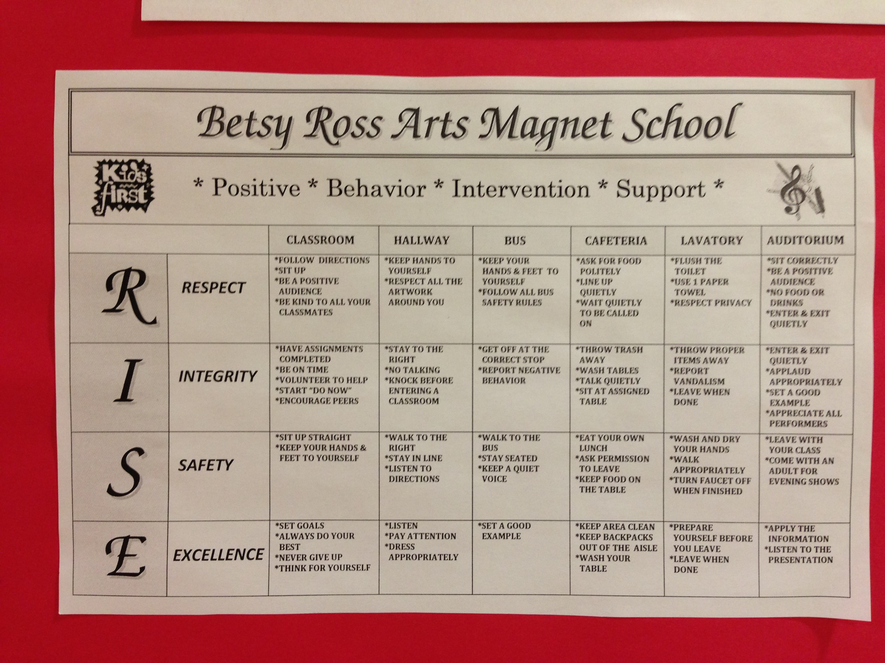
Going above and beyond the behavioral expectations will result in earning RISE dollars. Choosing not to follow the expectations will result in consequences (e.g. reflection paper, parent call, lunch detention, parent conference) and, more importantly, sacrificing valuable learning time.

Each class created their own class charter. You should have a copy of this in your binder for this class.
I acknowledge that I have read the syllabus and expectations for Ms. Tanyu’s class and will do my best to uphold the high standards Ms. Tanyu has set for me so that I may increase my opportunities in life.

Student’s Signature: _____________________________________________ Date: ___________

Parent’s Signature: ______________________________________________ Date: ___________

