Syllabus – 8th Grade English Language Arts, Ms. Tanyu
Room 236, Ext. 2236
Ms.Tanyu@gmail.com
http://www.rossarts.org/ms-tanyu.html

Terms to Know:
- syllabus – an outline and summary of topics to be covered in this class
- course number – a number given to a class at college to identify it
- essential question (EQ) – the big, important concept or idea

Course Number | Description & Essential Questions (EQ) | Dates & Tasks
ELA801 | In the first marking period, students will explore the concept of identity and how one’s identity is shaped. As students begin the year with Walter Dean Myers’ Monster, they will be compelled to truly think about the role society plays in our lives. Students will also collaborate in small groups (called literature circles) to determine characterization and theme in other fiction texts.  EQ: Who is stronger: the society or the individual? | 1st Quarter: 8/31/15-11/6/15  Required Writing Task:  Biographical Narrative  Open House: Tues. 9/29/15  Report Card Night: 11/18/15
ELA802 | The second marking period focuses on nonfiction texts. The core novel for this quarter is Chris Crowe’s compelling book Getting Away with Murder, the true story of the Emmett Till case. Students will also collaborate in small groups (called power strategy groups) to analyze other nonfiction works.  EQ: How can one event change our life forever? What is justice? | 2nd Quarter: 11/9/15-1/22/16  Required Writing Task: Informational Research Paper on Controversial Issue
ELA803 | “Natural and man-made disasters have the power to destroy thousands of lives very quickly.” Students will explore several catastrophes in Brenda Guiberson’s Disasters. This quarter will have a strong focus on building research skills.  EQ: How do disasters impact an individual or society? What does one’s response to disaster reveal? How do we analyze evidence for its relevance and validity? | 3rd Quarter: 1/25/16-4/15/16  Required Writing Task:  Research-based Argumentative Essay about Historical or Scientific Issue  Report Card Night: 4/27/16
ELA804 | Students end the year again with fiction, with the core novel of Kristen Randle’s Slumming, a realistic piece about the challenges a group of three high school students face. Students will reconvene in literature circles to explore characterization, conflict, and theme.  EQ: What does it mean to be an individual? How do our peers influence us? | 4th Quarter: 4/25/16-6/20/16  Required Writing Task:  Literary Analysis

Grading Breakdown: 50% Tests/Quizzes/Writing Pieces/Projects, 25% Classwork, 25% Homework

Behavioral Expectations
Ms. Tanyu – 8th grade English Language Arts (Reading & Writing)
Room 236, Ext. 2236
Ms.Tanyu@gmail.com

Terms to Know:
- motto – a saying or phrase that summarizes the general motivation of a group
- code of conduct – a set of rules outlining the responsibilities of individuals and a group

Our class motto is college-bound, self-driven.
College-bound means having the necessary skills to go to college after high school.
Self-driven means being motivated to accomplish something for yourself.

How should we act to show we are college-bound and self-driven? We act under the guidelines of RISE:
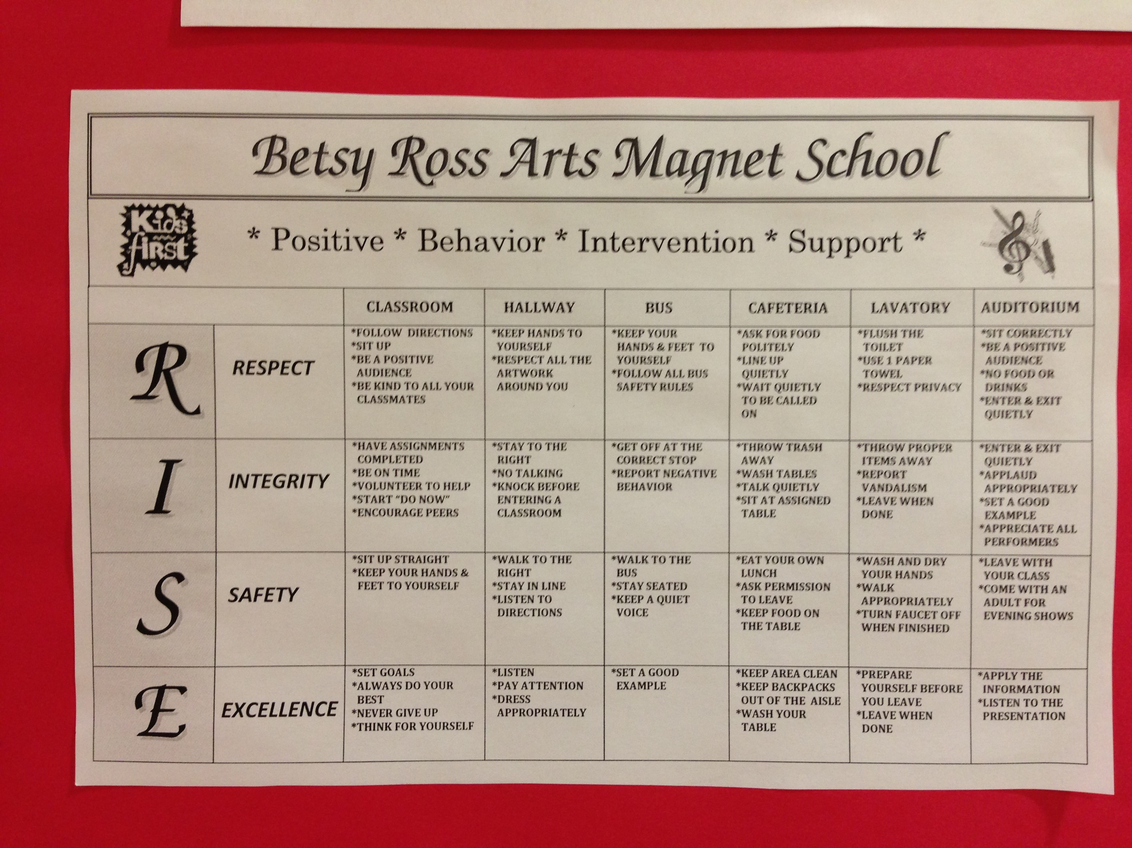
Going above and beyond the behavioral expectations will result in earning RISE dollars. Choosing not to follow the expectations will result in consequences (e.g. reflection paper, parent call, lunch detention, parent conference) and, more importantly, sacrificing valuable learning time.

Each class created their own class charter. You should have a copy of this in your binder for this class.
I acknowledge that I have read the syllabus and expectations for Ms. Tanyu’s class and will do my best to uphold the high standards Ms. Tanyu has set for me so that I may increase my opportunities in life.

Student’s Signature: _____________________________________________ Date: ___________

Parent’s Signature: ______________________________________________ Date: ___________

